<AIG>
< Cognizant >
KT Play Back



 | Prepared By / Last Updated By | Reviewed by | Approved By
Name | Dino Ding
Role | Team Member
Signature | Dino Ding
Date | 11/23/2020

Contents
Contents
1.0 Environment Setup 4
1.1 DB Setup 4
1.2 Dev Environment 4
2.0 Application 4
2.1 Application overall Architecture 4
2.2 Application Front end 5
2.3 Application internal & external interface 5
2.4 User Roles & privileges 5
2.5 Type of channel details 6
2.6 Database Architecture 6
2.7 Payment gate way service details 6
2.8 Third Part Payment interface details 7
2.9 Email & SMS service details. 7
2.10 Application Server details (SIT/UAT/PROD Servers) and Data center information 7
2.11 Data Flow details 7
3.0 Technical 7
3.1 Application Architecture 7
3.2 Common libraries used in the application 10
3.3 Coding standards and checklist 11
3.4 Source Code path and version control Details 11
3.5 Ongoing enhancements 11
3.6 CR Signoff process/Backout process/Code retrofit process and Testing 11
3.7 Release Management Activities specific 11
4.0 Error Handling 11
4.1 Error Logs Debugging process 12
4.2 Error Log path & Server details 12
5.0 Deployment Process 12
5.1 Production deployment procedure 12
5.2 OCM communication process & CAB approval process 12
5.3 Post implementation procedure 12
5.4 Roll Back process 12
6.0 Interfaces 12
6.1 Application Interface details 12
6.2 Third party component interface details 12
6.3 Web Service / API data flow interface details 12
6.4 Upstream and Downstream dependencies 12
7.0 Team Email (Business Leader/Manager, IT , DBA) 12

Environment Setup

DB Setup
- Sybase 12.5.4

Dev Environment
软件:
Office 2010
Sybase 12.5.1driver
Sybase 12.5.4driver
S3 Components
CRE_TP G04.07
CRE_S3
Visual Basic 6.0


Application

Application overall Architecture
- 系统简介
IHUB作为整合上下游的中间系统，把符合的数据从上游传送到下游系统。
- Liberty数据通过IHUB，ihub通过报文头的解析，把数据放到不同的库里，等待后续处理。保单和Billing会先book到tips，保单到tips就结束，Billing触发group再次调用到下游系统。
- IHUB也会把IPA的保单book到GOALD
Note :
大保单 ：小保单根据billing规则合并后存入GOALD。 一个Billing可能对应多个大保单，group规则由Liberty确定
TIPS: 传到TIPS的有保单和Billing. 保单以小保单传入TIPS，Billing会触发group，根据Billing的数据把小保单group成大保单，生成虚拟的保单号存到GOALD。
- 系统架构
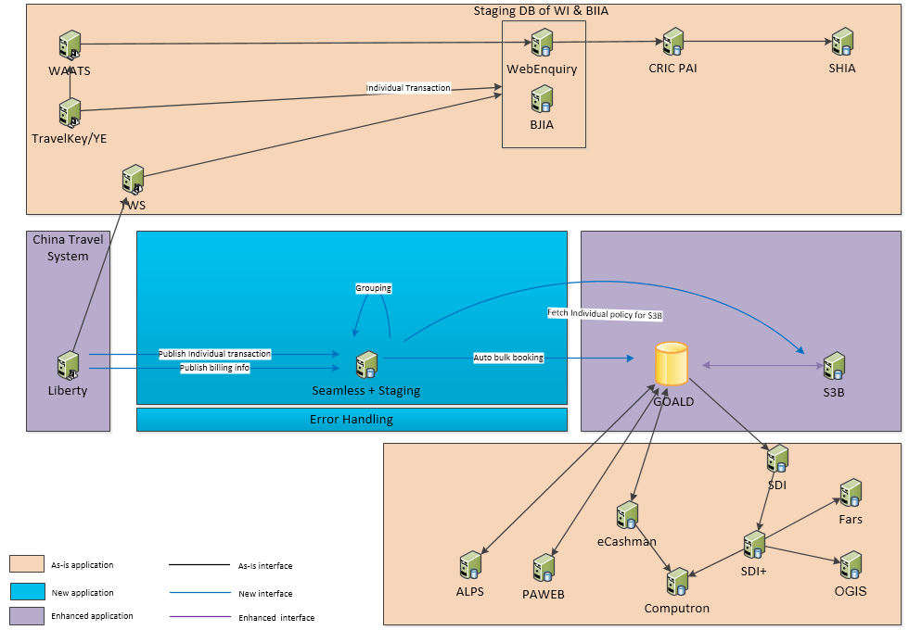
- 系统下游

Application Front end
NA

Application internal & external interface
- Internal interface
- External interface

User Roles & privileges
NA

Type of channel details
NA

Database Architecture
- Users&Roles
- Tables
Main Tables
Table Name | Description
tpolkey | 保单主键表
tpolicy | 保单表
tpolicy_bc | 保单明细表
tpolprm | 保单保费表
tprmchg | 保费charge表
tpolcomm | 保单手续费表
tpolcomm_bc | 保单手续费明细表
tpolchg | 保单税务charge表
tprmcomm | 保费手续费表(补充信息)
tprmdets | 保费明细表
tproduct | 产品表
tproduct_bc | 产品明细表
tsection | 保单section表
trisk | 保单risk表
tcovrage | 保单coverage表
tcovrage_bc | 保单coverage表
tprmtrxn | 保费事务表
triattch | RI的treaty,liability等相关表
trilayer | RI的treaty,liability等相关表
triliab | RI的treaty,liability等相关表
tpoldebits | 财务销帐相关表
tsdiprm | SDI相关表
tsdiprmt | SDI相关表
tbilling_polcharge | Billing相关表
tbilling_polinfo | Billing相关表
tbilling_polinfobc | Billing相关表
tbilling_polinst | Billing相关表
tbilling_polinstcharge | Billing相关表

Master Tables
Table Name | Description
tproduct | 产品表
tproduct_bc | 产品明细表
tprduer | 保险销售代表/保险公司表
Tclient | 客户表
tclienti | 客户表(个人)
Tclienti_BC | 客户明细表(个人)
tcliento | 客户表(企业)
tcliento_bc | 客户明细表(企业)

Code Tables
Table Name | Description
treftab | 代码参考表

Ihub Config Tables
Table Name | Description

Ihub Audit / log
Table Name | Description
T_CS_EVENT_AGGREGATION | Event聚合信息
T_CS_EVENT_AUDIT | audit信息
T_CS_EVENT_COMMAND
T_CS_EVENT_EXCEPTION | 异常表
T_CS_EVENT_EXTENSION | event扩展表
T_CS_EVENT_INDEX | event主表
T_CS_EVENT_LOG | event log表
T_CS_EVENT_LOG_DETAIL | event log详情表
T_CS_EVENT_MONITOR | event监控表
T_CS_EVENT_PAYLOAD | event事件详情
T_CS_EVENT_RAW_DATA
T_CS_EVENT_REPLAY
T_CS_EVENT_STATUS | event状态表
T_CS_EVENT_TRANSACTION_DETAIL | event事务信息

Ihub data table
Table name | Description
_i_ | 小保单
_b_ | billing
_g_ | group

- Store procedures
调用
- Data model
- Other

Payment gate way service details

Third Part Payment interface details

Email & SMS service details.

Application Server details (SIT/UAT/PROD Servers) and Data center information
Application component | Environment | Host name | DB name | IP address/Port no | Contact team
APPLICATION | PROD
APPLICATION | UAT
DATABASE-ALPS CL | PROD
DATABASE-ALPS CL | PROD
DATABASE-ALPS CL | UAT
DATABASE-ALPS CL | UAT

Data Flow details
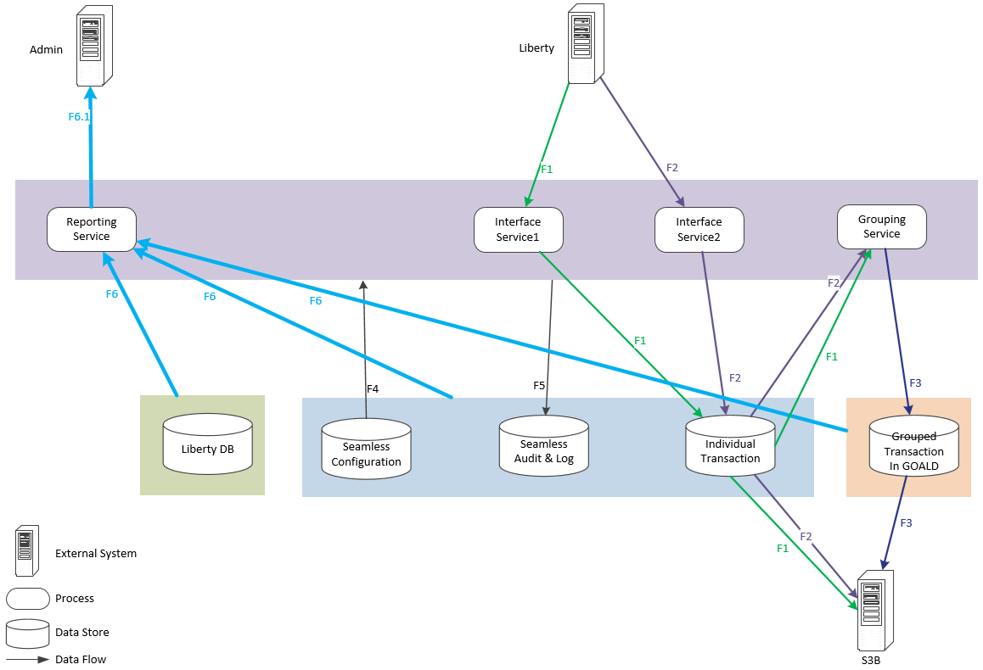
Data flow name | Security | Existing or new | Data | description
F1 | Sensitive Personal Info | New | Policy_no, Insured name, etc,.. | Individual policy information
F2 | Sensitive Personal Info | New | Policy_no, billing_no,etc,.. | Individual policy information
F3 | Sensitive Grouped Info | New | Group_No, etc,.. | Grouped information
F4 | Configuration Info | New | Billing data, etc,.. | Seamless configuration data
F5 | Audit & Log Info | New | Date, task, no, etc,.. | Audit & Log Info
F6 | Sensitive Personal Info | New | Policy_no, Insured name, etc,.. | All of the data which are stored in all of the Data Store
F6.1 | Sensitive Personal Info | New | Policy_no, Insured name, etc,.. | The report data

Technical

Application Architecture
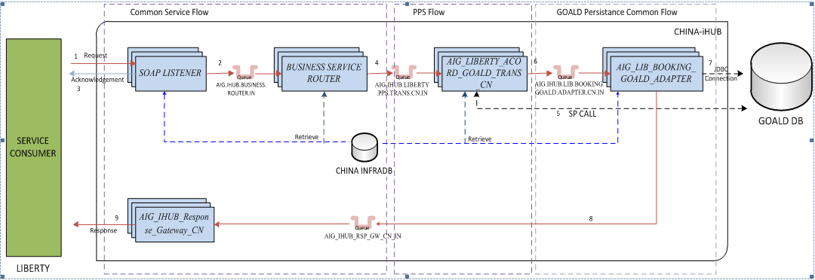
- Technical overview
- Model overview

- Model

- SOAP Listener 模块

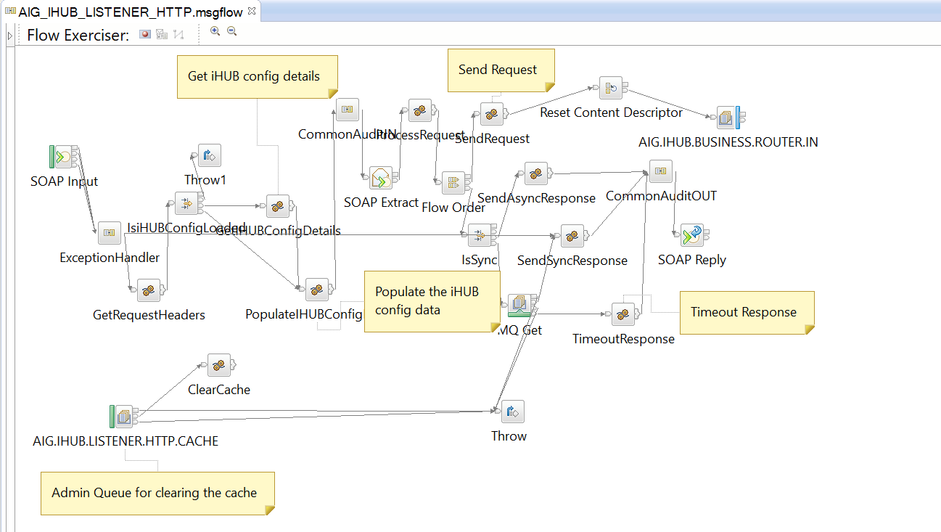
功能：consumer通过调用iHub提供的webservice接口，将xml info发送到iHub，SOAP LISTNER处理请求数据，将收到的数据放入AIG.IHUB.BUSINESS.ROUTER.IN中，验证数据头节点的正确性，并将结果放回给consumer
相关数据库操作： 获取IHub config 信息，
SELECT T1.*,T2.SERVICE_TYPE,T2.CONSUMER,T2.COUNTRY,T2.MAX_RETRY,T2.REPLAY_INTERVAL,T2.RECEIVER
FROM T_CS_IHUB_GATEWAY_CONFIG T1,
T_CS_IHUB_SERVICE_LIST T2
WHERE T1.GATEWAY_MODE = ?
AND T1.SERVICE_ID = T2.SERVICE_ID
AND T1.ENABLE = ?
相关队列信息：
MQGet : 读取消息Queue name - AIG.IHUB.LISTENER.OUT
AIG.IHUB.LISTENER.HTTP.CACHE: 接收消息 - Queue name - AIG.IHUB.LISTENER.HTTP.CACHE
AIG.IHUB.BUSINESS.ROUTER.IN : 发送消息 msg – Queue name -- AIG.IHUB.BUSINESS.ROUTER.IN
相关Soap操作：
GetRequestHeaders: 获取soap header信息，如 RqUID
IsiHUBConfigLoaded ： 查看ihub config是否已经load ( DB_IHUB_CONFIG.valid)
PopulateIHUBConfigData： commonMessageValidation-验证request信息
ProcessRequest ：设置output信息
isSync ：check Environment.Variables.RequestHeader.ihubConfigDetails.COMMUNICATION_TYPE = 'SYNC'
SendAsyncResponse : 设置response信息
- Business Service Router
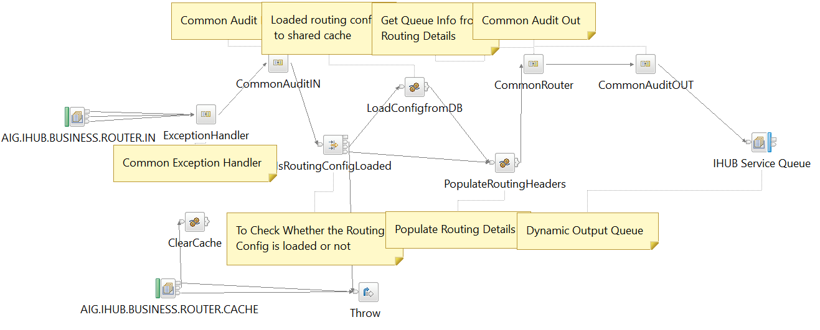
功能：BUSINESS SERVICE ROUTER接收消息 AIG.IHUB.BUSINESS.ROUTER.IN，将根据数据库中预存的分发规则将数据进行处理，并将message放到AIG.IHUB.LIBERTY_PPS.TRANS.IN
数据库操作：
SELECT * FROM Database.T_CS_IHUB_ROUTING_CONFIG AS RC WHERE RC.ENABLE = 'Y'
MQ操作:
接收消息：AIG.IHUB.BUSINESS.ROUTER.CACHE
接收消息：AIG.IHUB.BUSINESS.ROUTER.IN
发送消息：按照分发规则

- Trans CN ★
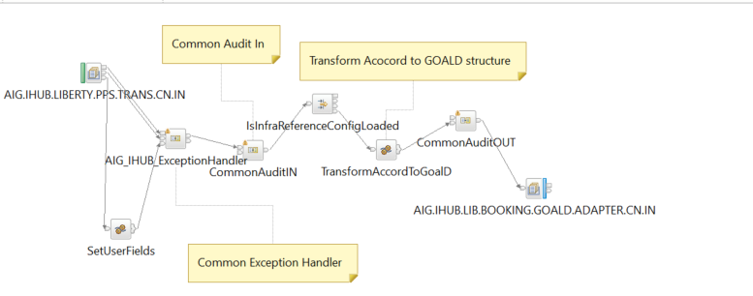
调用Goald数据库的sp, Do the mapping, generate insert script for next message flow.
数据库相关操作：
调用 ssp ihub_pps_goald_call
CALL ihub_pps_goald_call(Environment.PolicyNumber,cPolOfficeCd,
CAST(Environment.PolicyVersion AS INTEGER),CAST(rAccordMsgRef.acord:Policy.acord:EndorsementNumber AS INTEGER),rAccordMsgRef.acord:Policy.acord:ActionCd,producer_cd,
cPolOfficeCd,IHUBUSERID,'Y','Y','Y','Y','Y','Y','Y',OutputLocalEnvironment.Variables.GOALDVALIDATIONSP.RESULT[],
OutputLocalEnvironment.Variables.PreviousSectionCdList[],
OutputLocalEnvironment.Variables.AIINFO[]);
生成以下sql语句：
插入数据到SI_I_TADDRESS，SI_I_TPRMTRXN，SI_I_TPHONE，SI_I_TTEXT or SI_I_TTEXT_BC （根据text_detail的长度决定254），SI_I_TCLIENT，SI_I_TCLIENTI,SI_I_TCLIENTO，SI_I_TPOLKEY，SI_I_TPOLICY，SI_I_TPOLLOC
如果有endorsement change of plan, mark the earlier record in GOALD as cancelced with end_act_cd(E)，然后插入一条新记录
SI_I_TPOLADJ，SI_I_TPRMTRXN
MQ处理：
接收消息AIG.IHUB.LIBERTY.PPS.TRANS.CN.IN
发送消息AIG.IHUB.LIB.BOOKING.GOALD.ADAPTER.CN.IN
- Trans CN Billing ★
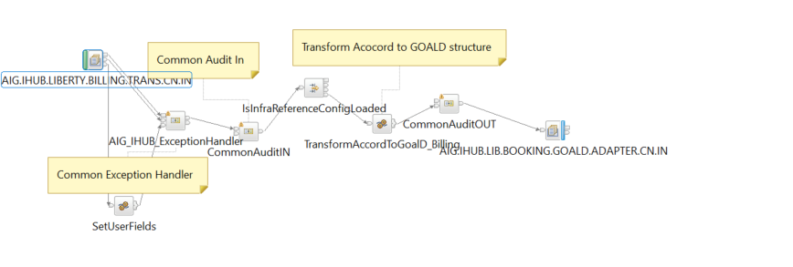
验证：
billingNo/billingSequenceNo不能为空
数据库相关操作：
生成sql：插入数据到表SI_B_BILLING，SI_B_BILLING_POLICY
MQ处理：
接收消息AIG.IHUB.LIBERTY.BILLING.TRANS.CN.IN
发送消息AIG.IHUB.LIB.BOOKING.GOALD.ADAPTER.CN.IN
参数：
设置Environment.GOALD.isFromBilling = 'true';
set the swith for java to invoke the SP, next please refer to "AIG_IHUB_COMMON_GOALD_ADAPTER_InsertToGoalD.java"

- GOALD_ADAPTER
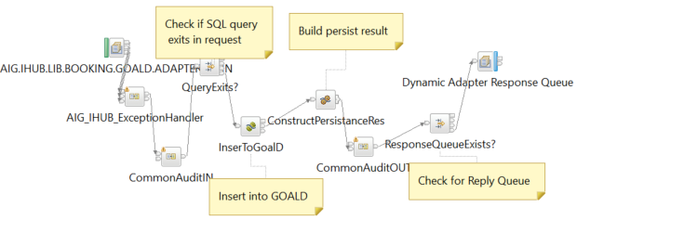
连接Goald数据库，执行Insert操作
数据库相关操作：执行insert语句，插入数据到Goald

MQ相关操作：
接收消息AIG.IHUB.LIB.BOOKING.GOALD.ADAPTER.CN.IN
发送消息：response queues
- Goald Direct adapter
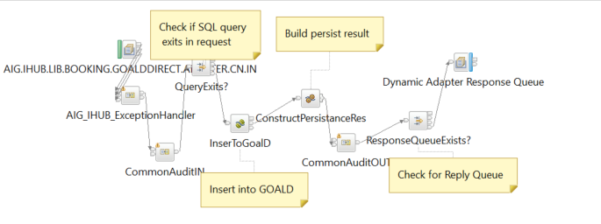

MQ相关操作:
接收消息AIG.IHUB.LIB.BOOKING.GOALDDIRECT.ADAPTER.CN.IN
- Goald Adapter – Call sp
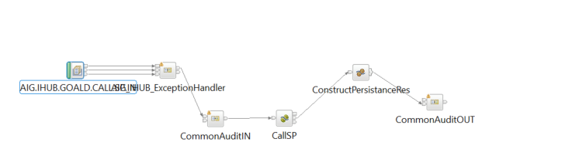
数据库操作：
如果from Billing,则调用sp
call SP_SI_Main('"+billingNo + "'," + billingSequenceNo + ",'" + producerCode + "')
MQ操作：
读取消息AIG.IHUB.GOALD.CALL.SP.IN
- Response Gateway
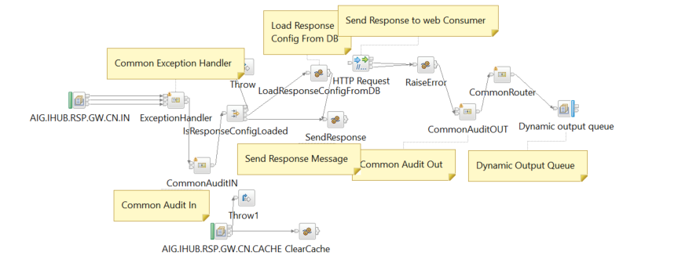
数据库操作：
读取表T_CS_IHUB_GATEWAY_CONFIG --- 获取response配置信息
读取表T_CS_EVENT_REPLAY –查看COMMON_TRANS_ID是否存在s
Response ：
http://webservices.travelguard.com/PBS/2015/08/IPolicyBookingStatus/SendPolicyStatus

MQ操作：
读取消息AIG.IHUB.RSP.GW.CN.IN
- Event Handler
s

- Dependency

Common libraries used in the application
- Business objects
- Utilities
- Exceptions
- Logging
- Enterprise libraries

Coding standards and checklist
- TBD

Source Code path and version control Details
- TBD

Ongoing enhancements
- If any

CR Signoff process/Backout process/Code retrofit process and Testing
- Signoff Process
- Backout process
- Code retrofit process
- Testing

Release Management Activities specific
- 记录并掌握发布管理

Error Handling

Error Logs Debugging process

Error Log path & Server details

Deployment Process

Production deployment procedure

OCM communication process & CAB approval process

Post implementation procedure

Roll Back process

Interfaces

Application Interface details

Third party component interface details

Web Service / API data flow interface details

Upstream and Downstream dependencies

Team Email (Business Leader/Manager, IT , DBA)

